Phase 4 — NiFi, Kafka & Spark
Q1. What is a FlowFile in Apache NiFi? Describe its two main components and explain what happens to a FlowFile when a processor fails.
A flowFile is a data record, which consists of a pointer to its content (payload) and attributes. Attributes act as the metadata for the FlowFile (ex: FlowFile filename). The content is the actual data or the payload of the file.

Q2. Build a NiFi flow that reads CSV files from a local folder, splits each row into individual FlowFiles, and writes them to a destination folder with the filename format: row_<n>.txt.
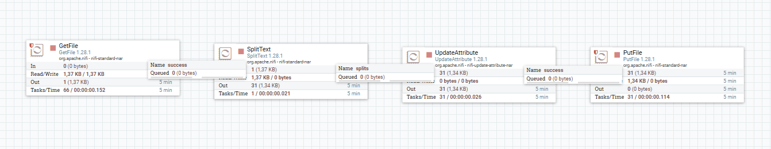

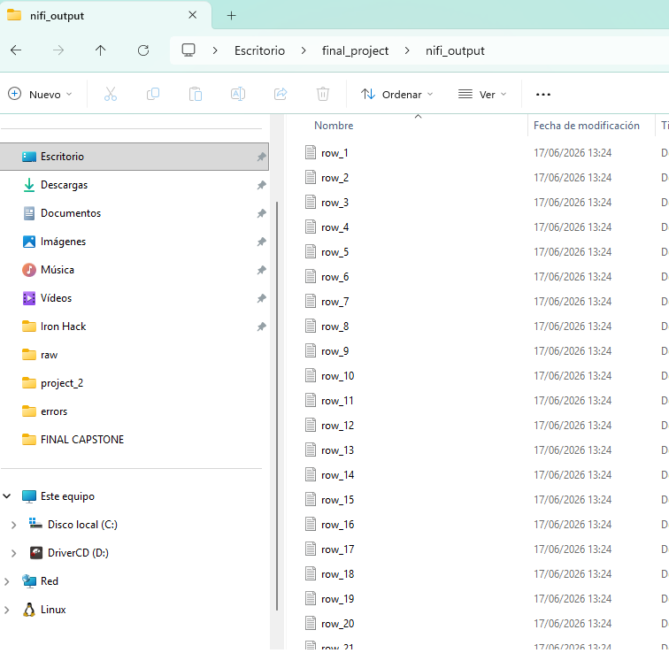
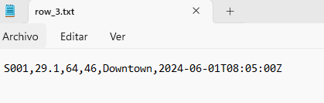
Q3. Explain the difference between 'Back Pressure Object Threshold' and 'Back Pressure Data Size Threshold' in a NiFi connection. When would you tune each?
Back Pressure Object Threshold: measures the total number of individual FlowFiles. For example if in the queue there are more than 10,000 FlowFiles, Bach pressure engages and upstream processor stops running until the downstream processor pulls files out and the count drops below the threshold,
Back Pressure Data Size Threshold: it Works the same but in this case the threshold is related to the volumen of bytes of all the FlowFile contents.
We tune the ‘Object Threshold’ when you have millions os really small files to keep data flowing smoothly. We tune ‘Data Size Threshold’ when having problems with disk space or when working with large files.

Q5. You need to ingest data from a Kafka topic in NiFi and merge every 1,000 records (or every 10 seconds, whichever comes first) into a single JSON array before writing to HDFS. How do you build this flow and what are the failure handling strategies?
[ConsumeKafka] --(success)--> [MergeContent] --(merged)--> [PutHDFS]
| | (failure) (original) (failure) (retry)
ConsumeKafka: pulls messages fron the Kafka topic and pulls them as individual FlowFiles.
MergeContent: merge the records.
Configurations:
- Maximun and Minimun Number of entries are set to 1000.
- Max Bin Age: 10 sec (this ensures that if 1000 records haven´t arrived within 10 seconds, the processor will be forced to merge and move on.
Error handling:
- Original relathionship: auto-terminate to avoid data duplication
- Failure relathionship: cconnect to LogAttribute to see the error in the logs
PutHDFS: writes the JSON array into HDFS.
- Failure relathionship (for example due to network partition) will be routed back into the processor input queue.

Q6. Explain the role of a Kafka broker, a topic, a partition, and a consumer group. Draw or describe how they relate to each other.
Broker: a single Kafka server. Receives messages from producers and pulls them to consumers.
Topic: category in which messages are stored.
Partition: topics are split into partitions across multiple brokers to achieve scalability.
Consumer group: collection of consumers that cooperate t oread data from a topic.
A topic is split into multiple partitions and distributed across different brokers to scale storage and performance. To read data efficiently, a consumer group divide the partitions among themselves so each partition is read by one consumer.

Q7. A Kafka consumer group has 5 consumers subscribed to a topic with 3 partitions. What happens? What if you later add 2 more partitions — describe the rebalance process.
As one partition can be assigned only to one consumer, therw would be 2 inactive consumers out of the 5. When increasing the partitions from 3 to 5, the number of partitions matches the number of consumers, triggering a group rebalance. This process is managed by a specific Kafka broker known as the Group Coordinator and is triggered whenever there is a change like adding new partitions.

Q8. Write a Python Kafka producer that reads rows from a CSV file and sends each row as a JSON message to a topic. Implement error handling and ensure at-least-once delivery using acks='all'.
See phase4_scripts -> q8_producer.py
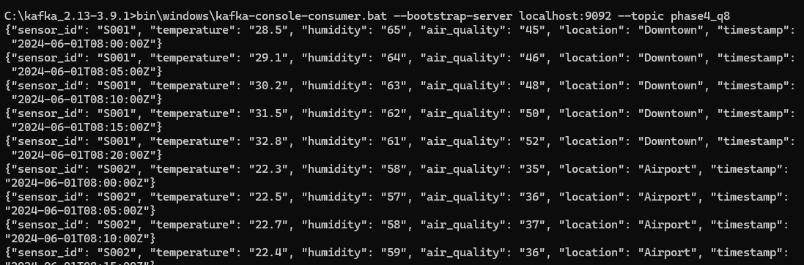
Q10. What is the difference between a Spark transformation and an action? Give 2 examples of each and explain why Spark uses lazy evaluation.
Transformation: define the logical execution plan. Examples: filter, join
Action: trigger the exxecution plan. Examples: count, collect
Lazy evaluation: transformations are not executed until an action is called to reduce memory usage and maximize performance.
Q11. You have two DataFrames: 'orders' (order_id, customer_id, amount) and 'customers' (customer_id, name, city). Write a Spark job that joins them, finds the top 5 customers by total spend per city, and writes the result as Parquet partitioned by city.
See phase4_scripts -> q11.py and folder “top_customers_by city”
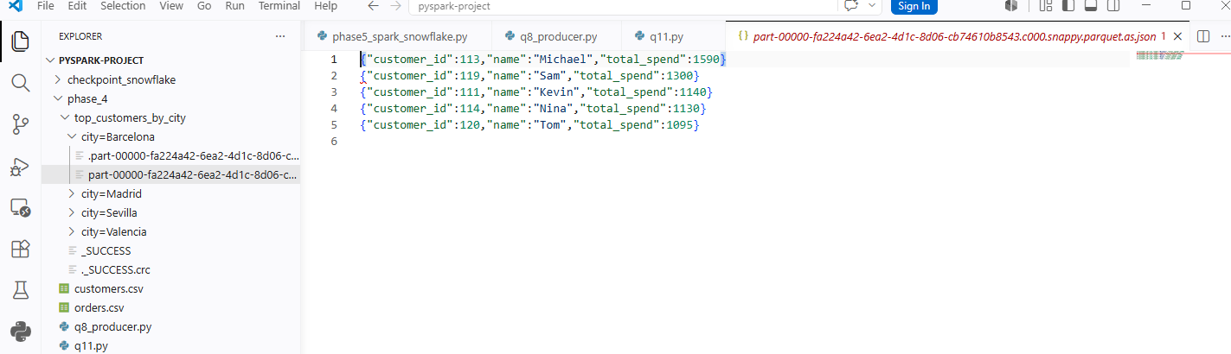

Q13. What is the difference between Spark Streaming (DStreams) and Structured Streaming?
Spark Streaming (DStreams): streaming data is processed as a continuous sequence of small RDDs, following a micro-batch model.
Structure Streaming: treats streaming data as an append-only table that gets updated in real-time.

Q15. A Structured Streaming job using a 10-minute window is missing events that arrive 3 minutes late. How do you handle late data in Spark Structured Streaming? What is watermarking?
This streaming job is missing events that arrive 3 minutes late, discarding them before they can be processed. To handle-late arriving data Spark Structure Streaming uses a feature called Watermarking. A watermark is a threshold that tells Spark how far back in time should keep track of old data. Therefore, to not miss 3-minute late events, you must define a watermark before defining the time window to set the allowed time delay to something higher than 3 minutes.

Q16. Design a Structured Streaming pipeline that reads IoT sensor data from Kafka (sensor_id, temperature, ts), detects anomalies (temperature > 3 standard deviations from the 1-hour rolling mean per sensor), and writes alerts to a Kafka alerts topic AND to Snowflake for long-term storage.
See phase4_scripts -> q16.py
Q18. A retail company wants to build a real-time analytics platform. Data arrives via point-of-sale systems. Describe which tools you'd use at each stage (ingestion, streaming, storage, visualization) and justify your choices.
POS systems -> Kafka -> Strucutred Streaming -> Snowflake -> Tableau/PowerBi
- Ingestion
  - Kafka: Point-of-sale (POS) systems generate a continuous, high-volume stream of transactional events. Kafka can handle millions of events per second with minimal latency. Besides, if downstream processing fails, Kafka is able to retain the data on disk, avoiding data loss.
- Streaming
  - Spark Structured Streaming: processes real-time data, cleaning it and calculating live metrics. It can handle late data using watermarking.
- Storage
  - Snowflake: the retail company needs to store historical data but also today´s data. Snowflake allows streaming live transactions into a database without interfering with the business analytics.
- Visualization:
  - Tableau/Power BI: they allow live connection to Snowflake getting dashboards that refresh automatically.

Q19. Design and implement a late-data handling strategy: IoT sensor events flow through Kafka into Spark Structured Streaming. Some events arrive up to 10 minutes late. Aggregated results must land in Snowflake. Power BI must show both the latest aggregates AND a 'corrections history' when late data updates a previous window. Describe the architecture and key implementation decisions.
- Producer.py (IoT sensors with delayed data)
- Kafka (topic = iot_data)
- Spark Structured Streaming
  - Read data from Kafka
  - Clean data and apply 10-minute Watermark
  - Calculate 5-minute Window Aggregations
  - Append updates cleanly to Snowflake
- Snowflake
- PowerBi

